SALE OF CANSON MI-TEINTES PASTEL PAPER IN TWO SIZES
https://en.canson.com/mi-teintesr
Available to pick up from Bishops Lydeard, Somerset by appointment. Delivery possible – please get in touch to discuss either postage of cut down sheets or delivery if local. Sarahwatkin17@gmail.com
*** All prices below negotiable ***
Canson Mi-Teintes Pastel Paper, 160 gsm, 50x65 cm
Selling in packs based on price of £1 a sheet (RRP £2.30 per sheet)

Pack of 16 sheets of 453 Orange - £16 | 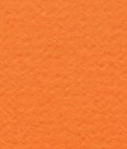
Pack of 5 sheets of 595 Turquoise - £5 | 
Pack of 14 sheets of 553 cadmium yellow - £14 | 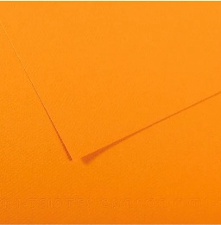
We do not have an exact shade code for the following:

Pack of 10 sheets brown - £10 | 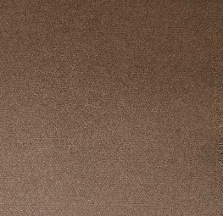
Pack of 9 sheets dark grey - £9 | 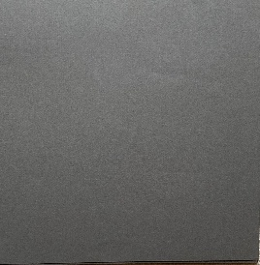
Pack of 18 sheets of blue tones.13 cornflower blue, 2 bright/turquoise blue, 3 Air Force blue - £18 | 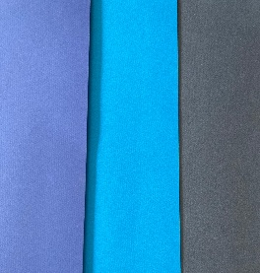
Canson Mi-Teintes Pastel Paper, 160 gsm, 55x75 cm
Selling in packs based on price of £1 a sheet (RRP £2.30 per sheet)

Pack of 24 sheets of 504 Rouille (rust) - £24 | 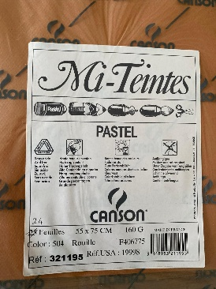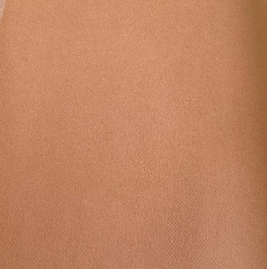
Pack of 23 sheets of Havane Clair (a kind of toffee brown) - £23 | 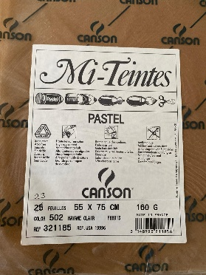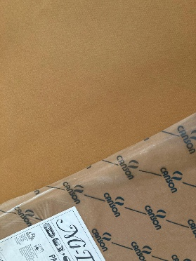
Pack of 6 sheets of 340 Chanvre Clair (oyster) - £6 | 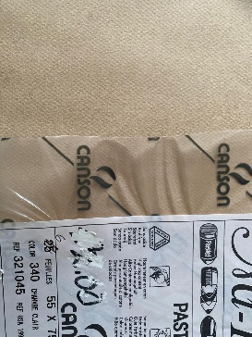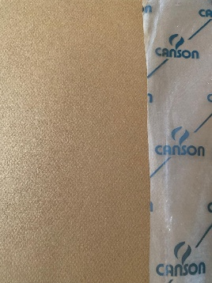
Pack of 7 sheets of 352 Rose Fonce (a dusky pink) - £7 | 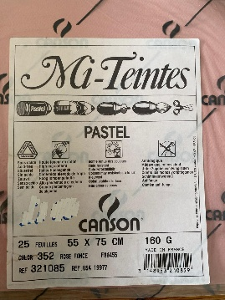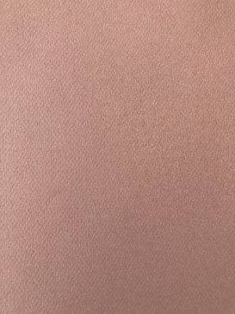
Pack of 15 sheets of 343 Gris Trianon (pearl) - £15 | 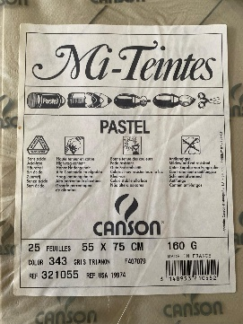
Pack of 14 sheets of 495 Bleu Roi (mid to dark blue) - £14  A few sheets (around 6) have a crease on one corner. | 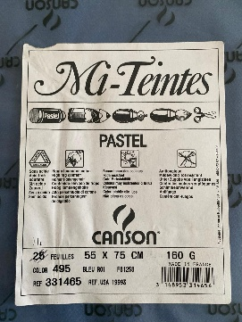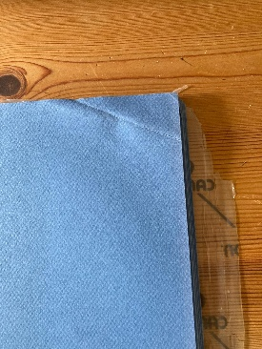
Pack of 16 sheets of 111 ivoire - £16 | 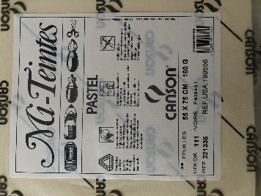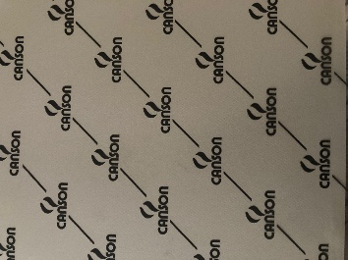
Pack of 8 sheets of 426 Gris Clair (moonstone) - £8 | 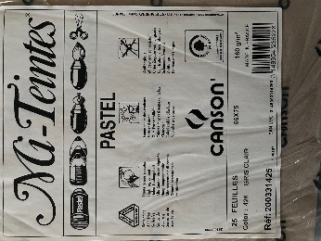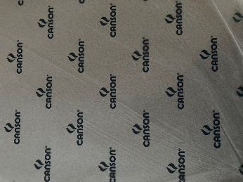
Pack of 16 sheets of 335 white - £16 | 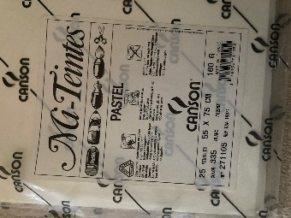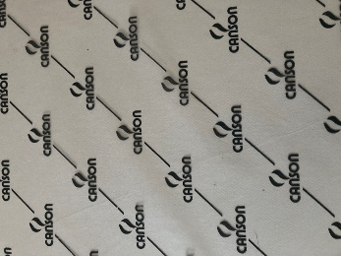
Pack of 25 sheets of 335 white - £25 | 