SALE OF WATERCOLOUR PAPER – AQUARELLE ARCHES, BOCKFORD & SOMERSET VELVET
Available to pick up from Bishops Lydeard, Somerset by appointment. Delivery possible – please get in touch to discuss either postage of cut down sheets or delivery if local. Sarahwatkin17@gmail.com
*** All prices below negotiable ***
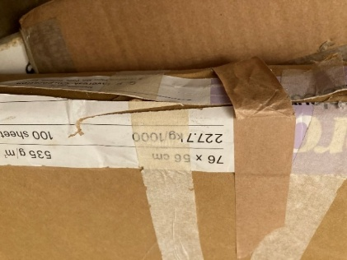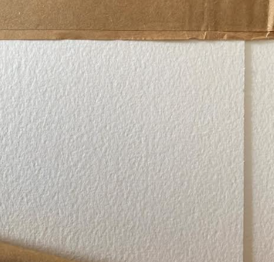 | Bockingford  535 gsm  76 x 56 cm  47 sheets  RRP: £7.40 per sheet  PRICE: 47 x £3 per sheet = £141  Smaller packs available
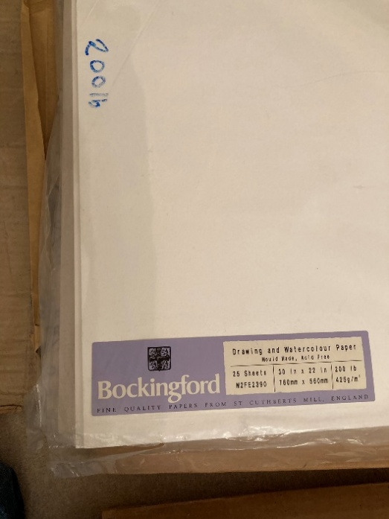 | Bockingford  425 gsm  56 x 76 cm  12 sheets  RRP: £5.90 per sheet  12 sheets x £2.50 per sheet = £30
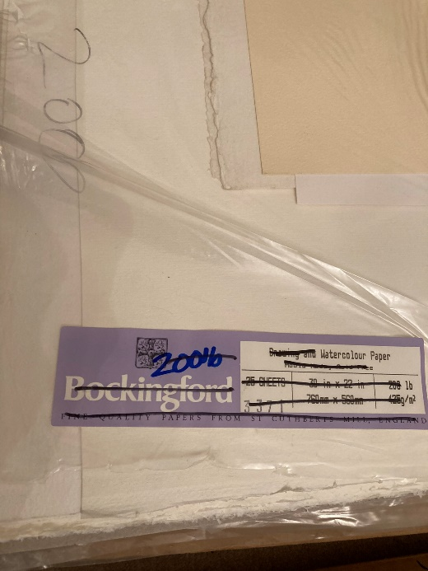 | Bockingford  425 gsm  56 x 76 cm  14 sheets  RRP: £5.90 per sheet  14 sheets x £2.50 per sheet = £35
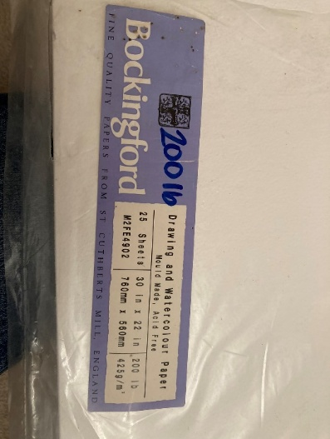 | Bockingford  425 gsm  56 x 76 cm  7 sheets  RRP: £5.90 per sheet  7 sheets x £2.50 per sheet = £17.50
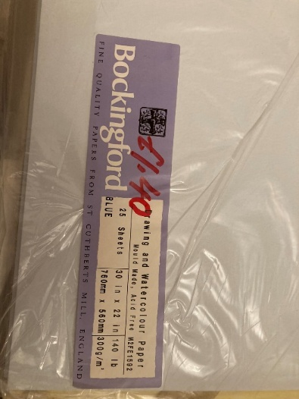 | Bockingford  “Blue”  300 gsm  56 x 76 cm  17 sheets  RRP: £4.15 per sheet  17 sheets x £1.40 per sheet = £23.80
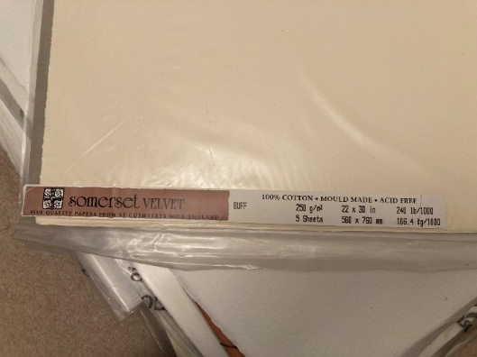 | Somerset Velvet  “Buff”  250 gsm  56 x 76  4 sheets  RRP: £5.74 per sheet  4 sheets x £1.50 per sheet = £6
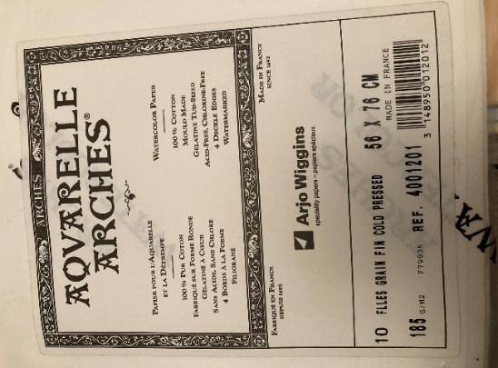 | Aquarelle Arches  185 gsm  56 x 76 cm  13 sheets  RRP: £5.40 per sheet  13 sheets x £1.53 per sheet = £20

